Changes made in 2014 year end update, please refer to all prior blogs of information.

Blog: January Hotfix – some ACA changes (Jan 2015)
https://community.dynamics.com/gp/b/dynamicsgp/archive/2015/01/23/draft-microsoft-dynamics-gp-2015-round-2-payroll-tax-update-what-you-need-to-know.aspx

Blog: ACA Information/Setup: (Nov 19, 2014)
https://community.dynamics.com/gp/b/dynamicsgp/archive/2014/11/19/draft-microsoft-dynamics-gp-2014-year-end-release-affordable-health-care-act-2.aspx

Blog: ACA Table/Column changes: (Nov 12, 2014)
https://community.dynamics.com/gp/b/dynamicsgp/archive/2014/11/12/table-and-column-changes-in-2014-year-end-update.aspx

Blog: ACA preliminary blog – view for all windows
https://community.dynamics.com/gp/b/dynamicsgp/archive/2014/09/23/aca.aspx

Last year Blog on Benefit Tracking and ACA and Hours (Video)
https://community.dynamics.com/gp/b/dynamicsgp/archive/2013/07/16/affordable-healthcare-act-are-you-prepared-and-are-you-using-microsoft-dynamics-gp-to-its-full-potential.aspx

Noted Outstanding Issues that will be FIXED in the 2015 Year-End Update due to release week of 11/23/2015
- The form has the year 2014 on it. The IRS has not released the 2015 form yet; this will change at year end.
The forms print with lines, no need to order forms, the instructions will also print with the forms.
- The offer of coverage may be off if you are using two different benefit codes for an employee.
Example
Terry is on plan INS on 1/1/15 1B 2C
6/30/2015 In the INS code I put None
I add code SPOUSE to Terry as of 7/1/2015 I put this as ACA codes 1C 2C
Create the year end wage file
For the full year, I'm all 1C 2C, I would expect to see some 1B 2C and I 'm not
If this was all on 1 code it works fine, it is because I switch the code names from INS to SPOUSE, then it causes an issue Your data will be fine, we will fix the code at year end when you create the year end wage file.
- Currently the system prints all dependents and employee (self) as that is in the dependent table.
Per IRS, instructions are stating if I'm NOT a self-Insured Plan, meaning the box is NOT marked in the print W2 window
You should not print the dependents or self in PART 3, currently Microsoft Dynamics GP is printing both all the time.
Example:
We are NOT a self-insured plan, meaning Part III of the 1095-C should be left completely blank. But every 1095-C that prints out is printing the employee under this section.
Your data will be fine, we will fix the code at year end when you create the year end wage file.
- Box 15 - Employee Share of Lowest Cost Monthly Premium
A lowest cost premium field will be added at the benefit setup and benefit enrollment to track the amount in box.
Once you install the year end update, you can roll this amount down on all your plans from the setup to employee , then it will be correct when you create the year end wage file. The summing of all boxes will also change.
Effective dating will also be added for this field.
- Remove Payroll Year - End information does not clear data from the new Year End ACA tables

Notes:
Microsoft Dynamics GP will NOT be supporting the 1094-B and 1095-B forms for small business employers of less than 50 employees.
Microsoft Dynamics GP will NOT support the electronic filing; here are some ISV solutions you can review

Here are some ISV’s that have worked in the ACA area and my offer these services, no particular order.
Aim-Technologies -http://www.aim-technologies.com/solutions.html
Greenshades - https://www.greenshades.com/
Sypnio Software/Integrity Data - http://www.integrity-data.com/
You can also search for solutions at - http://pinpoint.microsoft.com

- If your dependents are not creating with the year end wage file, verify there is NO 2014 date in the UPR00904 table.
If there are they could have been inserted with utilities when you installed the year end update last year, change the date to 1/1/2015, recreate the year end wage file and they will appear.
Typically we would not want 2014 dates in the UPR00905 nor the UPR00904

- If you see many “older” employees printing 1095-C than you want, it could be as records were inserted into the UPR00904 for those employees. You can remove those employees from the UPR00904 table and then the form will not print.
You will want to review your data and determine how you want to remove them.
Here are some sample scripts, change as you want based on your data.
DELETE UPR00904 WHERE EMPLOYID IN (SELECT EMPLOYID FROM UPR00100 WHERE INACTIVE = '1' AND DEMPINAC <= 'XXX-XX-XX 00:00:00.000')
DELETE UPR00905 WHERE EMPLOYID IN (SELECT EMPLOYID FROM UPR00100 WHERE INACTIVE = '1' AND DEMPINAC <= 'XXX-XX-XX 00:00:00.000')

Changes in the March hotfix 2015 for ACA(included in year end)

Based from all the tracking you have done after installing the 2014 year end update, it is now time to review the forms and data.
You will need to create the year end wage file for 2015 to review this data.
(the year end wage file will need to be removed prior to you running the next 2015 payroll, it would be best to do this in a test company that is a backup of your current live company click HERE for steps to create a test company.)

Click HERE if you need steps on how to create the year end wage file and remove it.

From the PRINT W-2 FORM window you will be able to print the forms

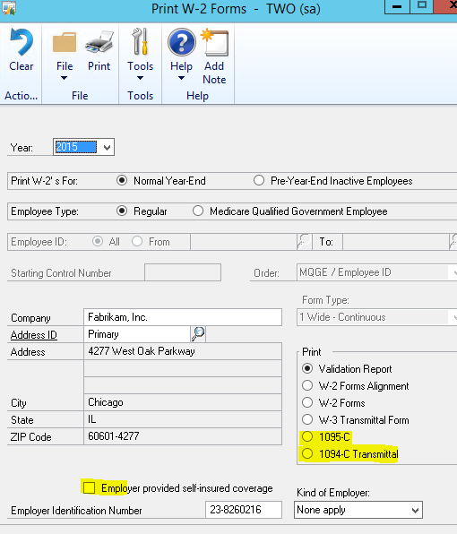
From the EDIT W-2 INFORMATION window you can edit / view the ACA information.
When you remove the year end wage file, all this information will be lost, similar to W2’s, then repopulated when you recreate the year end wage file.

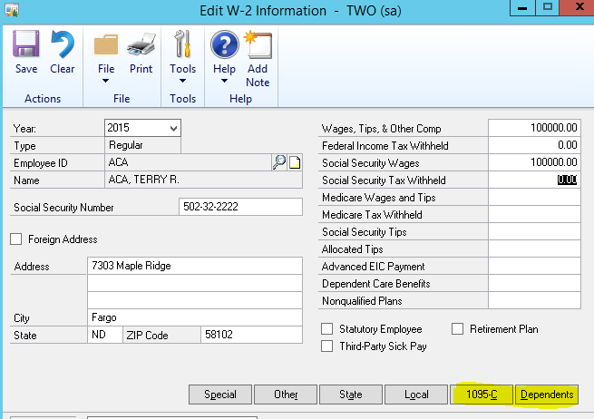

1095-C Employer Provided Health Insurance Offer and Coverage report

Void checkbox – no data yet
Corrected checkbox – no data yet

Part 1 – Employee

All employee information (name, SSN & address) is taken from the Employee record during the process to create the year end tables. This information can be edited in the Edit W-2 Information window.

All employer information is pulled from the existing year end tables, which can be edited in the Print W-2 window.

Part 2 – Employee Offer and Coverage

Offer of Coverage code
- This is determined by looking at the records in UPR00905 (uprMstrEmployeeACA)
- If the Offer of Coverage code has changed twice in one calendar month, the most recent change (based on the Effective Date field) is used. If for example we have made a change on the same day with 2 benefit codes, the system will take the latest change in the table for the month.
- If the Offer of Coverage code has not changed in the past calendar year, the most recent previous change (based on the Change Date field) is used.
  - For example, if the Payroll Year end is being run for 2016, but the last time the Offer of Coverage code was changed for an employee was November 2015, the system will use the code from November.

Employee Share of Lowest Cost Monthly Premium---changes made in 2015 Year end update
- Cost to Subscriber field on Health Insurance Enrollment; pulled from the Insurance code that has been active the longest.
- This will be the same value for every month; the only exception is if a month has an Offer of Coverage code of 1H or None. Then the value will be 0.
- You can edit this information in the Edit W-2 window as well if the amount is not correct.
(In the future, after 2015 year end, we may look to add a new field for this)
- If you need to make a mass change, this is stored in the following year end table UPR10111.
At year end time, you can easily do a script to mass change your values based on the lowest coverage that was offered to your employees.
Example scripts you can modify

Box 15 - Employee Share of Lowest Cost Monthly Premium
A lowest cost premium field will be added at the benefit setup and benefit enrollment to track the amount in box.
Once you install the year end update, you can roll this amount down on all your plans from the setup to employee , then it will be correct when you create the year end wage file.

UPDATE UPR10111 SET MonthofCost_1 ='50.00000'
UPDATE UPR10111 SET MonthofCost_2 ='50.00000'
UPDATE UPR10111 SET MonthofCost_3 ='50.00000'
UPDATE UPR10111 SET MonthofCost_4 ='50.00000'
UPDATE UPR10111 SET MonthofCost_5 ='50.00000'
UPDATE UPR10111 SET MonthofCost_6 ='50.00000'
UPDATE UPR10111 SET MonthofCost_7 ='50.00000'
UPDATE UPR10111 SET MonthofCost_8 ='50.00000'
UPDATE UPR10111 SET MonthofCost_9 ='50.00000'
UPDATE UPR10111 SET MonthofCost_10 ='50.00000'
UPDATE UPR10111 SET MonthofCost_11 ='50.00000'
UPDATE UPR10111 SET MonthofCost_12 ='50.00000'
where year1=2015

You could also do something like the below for each month if it should be updated by an amount that is there.
UPDATE UPR10111 SET MonthofCost_1 ='50.00000' where MonthofCost_1='25.00000' and year1=2015

Safe Harbor code
- The Safe Harbor code will be determined in the same manner as the Offer of Coverage code.

Misc Notes:
- If an employee has multiple Active Health Insurance Benefit records, the benefit used is the most recently updated (based on Effective Date).

Part 3 – Covered Individuals

Self-insurance coverage checkbox
This is pulled from the Employer provided self-insured coverage checkbox on the Print W-2 Forms window. When marked, the field on the report will be marked for all of the reports printed.
This is stored in the UPR10100 table new column employer_selfInsured as of 2015 March Hotfix.

Covered individuals (dependents)
- The data for this section originates from UPR00904 (uprMstrDependentACA); the payroll year end process goes through this data and populates UPR10109 (uprYearEndDependentACA) with records for the selected year.
- The records will print in order of sequence number, which is the order in which they were entered.
- Name, SSN, and DOB are all from the Employee Dependent window (uprMstrDependent table)
- Covered all 12 months is calculated during the payroll year end process based on the current dependent records. If the individual had coverage as of 1/31 of that payroll year, they would be considered covered (provided there were no later records that would change that)
- If an individual’s coverage changed more than once in a calendar month, the last record of that month would be the one used to determine coverage.
- An employee is considered not covered for a month, if that month had an Offer of Coverage code of 1H or None.
- If an individual’s coverage records start mid-year (for example, March), then they are considered to be not covered up to that point (so January and February checkboxes would be unmarked).

Year End tables of interest

- UPR10100 (UPR_Year_End_WORK_HDR)
  - Added Employer Self-Insured field
- UPR10108 (uprYearEndDependentACAHistory)
  - This is a copy of the uprMstrDependentACA table for the reporting year
- UPR10109 (uprYearEndDependentACA)
  - New table that contains the dependent data for Part 3 of the 1095-C report
- UPR10110 (uprYearEndEmployeeACAHistory)
  - This is a copy of the uprMstrEmployeeACA for the reporting year
- UPR10111 (uprYearEndEmployeeACA)
  - New table that contains the data for Part 2 of the 1095-C report

Forms Added/Updated

- Print W-2 (UPR_Year_End_Wage_Forms_Printing)
- Edit W-2 (UPR_Year_End_Editing_W2)

Reports Added/Updated

- 1094-C Transmittal of Employer Health Ins
- 1095-C Employer-Provided Health Insurance

Misc notes:

-If an employee does not have an insurance code assigned, they could still get a 1095-C printed for them, as long as they have a dependent record (table UPR00904)
-Employees that are marked as Inactive will get a 1095-C if they have a dependent record in UP00904.
-Employees that do not have wages but ACA data will also get a 1095-C

1094-C Transmittal of Employer Health Ins

Part 1
All employer information is pulled from the existing year end tables, which can be edited in the Print W-2 window.
**Fields that are blank are not currently stored in Microsoft Dynamics GP for this specific report**

Part 2
Not populated as information is not stored in Microsoft Dynamics GP.

Part 3
Not populated as information is not stored in Microsoft Dynamics GP.

If you reinstalled the sample company Fabrikam, you may not see the ACA codes in the look up. Run the below script to repopulate them, this is only an issue in Fabrikam company when you reload sample data.
insert into upr40105
(ten95line, ten95linecode, ten95linecodetext, ten95linedescription)
values
(1,1,'1A',' ')
insert into upr40105
(ten95line, ten95linecode, ten95linecodetext, ten95linedescription)
values
(1,2,'1B',' ')
insert into upr40105
(ten95line, ten95linecode, ten95linecodetext, ten95linedescription)
values
(1,3,'1C',' ')
insert into upr40105
(ten95line, ten95linecode, ten95linecodetext, ten95linedescription)
values
(1,4,'1D',' ')
insert into upr40105
(ten95line, ten95linecode, ten95linecodetext, ten95linedescription)
values
(1,5,'1E',' ')
insert into upr40105
(ten95line, ten95linecode, ten95linecodetext, ten95linedescription)
values
(1,6,'1F',' ')
insert into upr40105
(ten95line, ten95linecode, ten95linecodetext, ten95linedescription)
values
(1,7,'1G',' ')
insert into upr40105
(ten95line, ten95linecode, ten95linecodetext, ten95linedescription)
values
(1,8,'1H',' ')
insert into upr40105
(ten95line, ten95linecode, ten95linecodetext, ten95linedescription)
values
(1,9,'1I',' ')
insert into upr40105
(ten95line, ten95linecode, ten95linecodetext, ten95linedescription)
values
(2,1,'2A',' ')
insert into upr40105
(ten95line, ten95linecode, ten95linecodetext, ten95linedescription)
values
(2,2,'2B',' ')
insert into upr40105
(ten95line, ten95linecode, ten95linecodetext, ten95linedescription)
values
(2,3,'2C',' ')
insert into upr40105
(ten95line, ten95linecode, ten95linecodetext, ten95linedescription)
values
(2,4,'2D',' ')
insert into upr40105
(ten95line, ten95linecode, ten95linecodetext, ten95linedescription)
values
(2,5,'2E',' ')
insert into upr40105
(ten95line, ten95linecode, ten95linecodetext, ten95linedescription)
values
(2,6,'2F',' ')
insert into upr40105
(ten95line, ten95linecode, ten95linecodetext, ten95linedescription)
values
(2,7,'2G',' ')
insert into upr40105
(ten95line, ten95linecode, ten95linecodetext, ten95linedescription)
values
(2,8,'2H',' ')
insert into upr40105
(ten95line, ten95linecode, ten95linecodetext, ten95linedescription)
values
(2,9,'2I',' ')

