***Changes made in prior updates, please refer to all prior blogs of information posted***

ACA video – Latest

[https://youtu.be/gAeLUjozhUA](https://na01.safelinks.protection.outlook.com/?url=https%3a%2f%2fyoutu.be%2fgAeLUjozhUA&data=01%7c01%7ctheley%40microsoft.com%7c080f257e8282408497a908d301a791e5%7c72f988bf86f141af91ab2d7cd011db47%7c1&sdata=UGtl1tH3uGfrzqeAMrXFrWLjTeZvgzppiEMv6Z5pU1c%3d)

Blog: 2015 Year-End ACA changes – all you need to know!!!

<https://community.dynamics.com/gp/b/dynamicsgp/archive/2015/11/25/gpye2015aca>

Blog: U.S. Year end Update Released – list of fixes

<https://community.dynamics.com/gp/b/dynamicsgp/archive/2015/11/20/2015-u-s-year-end-update-has-released>

Blog : Table changes in GP 2015 Year end Update – ACA related

<https://community.dynamics.com/gp/b/dynamicsgp/archive/2015/11/05/microsoft-dynamics-gp-year-end-release-2015-table-and-column-changes-in-us-year-end-update>

Blog: March Hotfix – some ACA changes  (March 2015)

<https://community.dynamics.com/gp/b/dynamicsgp/archive/2015/04/01/the-march-hotfix-has-released-what-is-all-the-excitement-about>

Blog: January Hotfix – some ACA changes  (Jan 2015)

<https://community.dynamics.com/gp/b/dynamicsgp/archive/2015/01/23/draft-microsoft-dynamics-gp-2015-round-2-payroll-tax-update-what-you-need-to-know.aspx>

Blog: ACA Information/Setup:  (Nov 19, 2014)

<https://community.dynamics.com/gp/b/dynamicsgp/archive/2014/11/19/draft-microsoft-dynamics-gp-2014-year-end-release-affordable-health-care-act-2.aspx>

Blog: ACA Table/Column changes: (Nov 12, 2014)

<https://community.dynamics.com/gp/b/dynamicsgp/archive/2014/11/12/table-and-column-changes-in-2014-year-end-update.aspx>

Blog: ACA preliminary blog – view for all windows

<https://community.dynamics.com/gp/b/dynamicsgp/archive/2014/09/23/aca.aspx>

[Last year Blog on Benefit Tracking and ACA and Hours (Video)](https://community.dynamics.com/gp/b/dynamicsgp/archive/2013/07/16/affordable-healthcare-act-are-you-prepared-and-are-you-using-microsoft-dynamics-gp-to-its-full-potential.aspx)

<https://community.dynamics.com/gp/b/dynamicsgp/archive/2013/07/16/affordable-healthcare-act-are-you-prepared-and-are-you-using-microsoft-dynamics-gp-to-its-full-potential.aspx>

**ACA items after you installed the 2015 Year-End Update**

1. **We have noticed once you install the 2015 year end update and create the year end wage file, the print 1095-C routine is printing all employees instead of just employees with amounts.  Below is a script you can run to remove those records of zero from the year end table.  If you recreate the year end wage file, this will need to be run again.  This will be fixed in a future release.**

delete from upr10111

where (MonthofCost_1='0' AND MonthofCost_2='0' AND MonthofCost_3='0' AND MonthofCost_4='0'and

MonthofCost_5='0' AND MonthofCost_6='0' AND MonthofCost_7='0' AND MonthofCost_8='0' AND

MonthofCost_9='0' AND MonthofCost_10='0' and MonthofCost_11='0' AND MonthofCost_12='0' AND

MonthofCoverage_1='0' and MonthofCoverage_2='0' and MonthofCoverage_3='0' and MonthofCoverage_4='0'and

MonthofCoverage_5='0' AND MonthofCoverage_6='0' AND MonthofCoverage_7='0' AND MonthofCoverage_8='0' AND

MonthofCoverage_9='0' AND MonthofCoverage_10='0' AND MonthofCoverage_11='0' AND MonthofCoverage_12='0')

and YEAR1='2015'

1. After installing the 2015 Year-End Update on GP 2015 only the Human Resource Enrollment ACA field has a missing label.  I have modified the window to add the label back if you want you can download and import this new form and set security to it.    
   Copy this package file to a shared location, import the form

Go to Microsoft Dynamics GP >> Tools >> Customize > Customization Maintenance, click Import and import the package file you downloaded above.

Go to Microsoft Dynamics GP menu >> Tools >> Setup >> System >> Alternate/Modified Forms and Reports

* 1. Select the Alternate/Modified Forms and Reports ID used by the end user(s)
  2. Select a product of Human Resources.
  3. Select a Type of Windows
  4. Expand 3rd party, expand Health Insurance Enrollment and choose ‘Human Resources (Modified)’

Save the changes and confirm the window appears as expected.



**ACA items fixed in the 2015 Year-End Update due to release week of 11/23/2015**

1. The form has the year 2014 on it. The IRS has not released the 2015 form yet; this will change at year end.  
   The forms print with lines, no need to order forms, the instructions will also print with the forms.
2. The offer of coverage may be off if you are using two different benefit codes for an employee.  
   Example

Terry is on plan INS on 1/1/15 1B 2C

6/30/2015 In the INS code I put None

I add code SPOUSE to Terry as of 7/1/2015 I put this as ACA codes 1C 2C

Create the year end wage file

For the full year, I'm all 1C 2C, I would expect to see some 1B 2C and I 'm not

If this was all on 1 code it works fine, it is because I switch the code names from INS to SPOUSE, then it causes an issue Your data will be fine, we will fix the code at year end when you create the year end wage file.

1. Currently the system prints all dependents and employee (self) as that is in the dependent table.

Per IRS, instructions are stating if I'm NOT a self-Insured Plan, meaning the box is NOT marked in the print W2 window

You should not print the dependents or self in PART 3, currently Microsoft Dynamics GP is printing both all the time.

Example:  
We are NOT a self-insured plan, meaning Part III of the 1095-C should be left completely blank. But every 1095-C that prints out is printing the employee under this section.  
Your data will be fine, we will fix the code at year end when you create the year end wage file.

1. Box 15 - Employee Share of Lowest Cost Monthly Premium

A lowest cost premium field will be added at the benefit setup and benefit enrollment to track the amount in box.  
Once you install the year end update, you can roll this amount down on all your plans from the setup to employee , then it will be correct when you create the year end wage file. The summing of all boxes will also change.  
Effective dating will also be added for this field.

1. Remove Payroll Year - End information does not clear data from the new Year End ACA tables

**Notes:**

Microsoft Dynamics GP will NOT be supporting the 1094-B and 1095-B forms for small business employers of less than 50 employees.

Microsoft Dynamics GP will NOT support the electronic filing; here are some ISV solutions you can review

**Here are some ISV’s that have worked in the ACA area and my offer these services, no particular order.**

Aim-Technologies -http://www.aim-technologies.com/solutions.html

Greenshades - <https://www.greenshades.com/>

Sypnio Software/Integrity Data - <http://www.integrity-data.com/>

You can also search for solutions at - <http://pinpoint.microsoft.com>

* If your dependents are not creating with the year end wage file, verify there is NO 2014 date in the UPR00904 table.  
  If there are they could have been inserted with utilities when you installed the year end update last year, change the date to 1/1/2015, recreate the year end wage file and they will appear.

Typically we would not want 2014 dates in the UPR00905 nor the UPR00904

* If you see many “older” employees printing 1095-C than you want, it could be as records were inserted into the UPR00904 for those employees. You can remove those employees from the UPR00904 table and then the form will not print.  
  You will want to review your data and determine how you want to remove them.   
  Here are some sample scripts, change as you want based on your data.

*DELETE UPR00904 WHERE EMPLOYID IN (SELECT EMPLOYID FROM UPR00100 WHERE INACTIVE = '1' AND DEMPINAC <= 'XXX-XX-XX 00:00:00.000')*

*DELETE UPR00905 WHERE EMPLOYID IN (SELECT EMPLOYID FROM UPR00100 WHERE INACTIVE = '1' AND DEMPINAC <= 'XXX-XX-XX 00:00:00.000')*

***Changes in the March hotfix & Year-End 2015 for ACA(included in year end)***

Based from all the tracking you have done for ACA, it is now time to review the forms and data.  
We need to be cognizant that we are saving the ACA data based on your Microsoft Dynamics GP user date at the time you save the record. If you are back dating in, put your GP user date to 1/1/2015. Benefit Begins, Benefit Ends or Inactive boxes are not being used. If you do not want a code to be part of ACA, you should have None in the fields, example below.

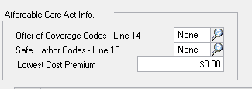

You will need to create the year end wage file for 2015 to review this data.

(the year end wage file will need to be removed prior to you running the next 2015 payroll, it would be best to do this in a test company that is a backup of your current live company click [HERE](https://support.microsoft.com/en-us/kb/871973/) for steps to create a test company.)

Click [HERE](https://mbs.microsoft.com/knowledgebase/KBDisplay.aspx?scid=kb;EN-US;856808) if you need steps on how to create the year end wage file and remove it.

Click [HERE](https://mbs.microsoft.com/Files/customer/GP/Downloads/TaxUpdates/ACAVIEW.docx) to create a SmartList Designer Report of ACA information.

Click [HERE](https://www.irs.gov/instructions/i109495c/ar01.html#d0e72) for IRS form instructions.

From the PRINT W-2 FORM window you will be able to print the forms

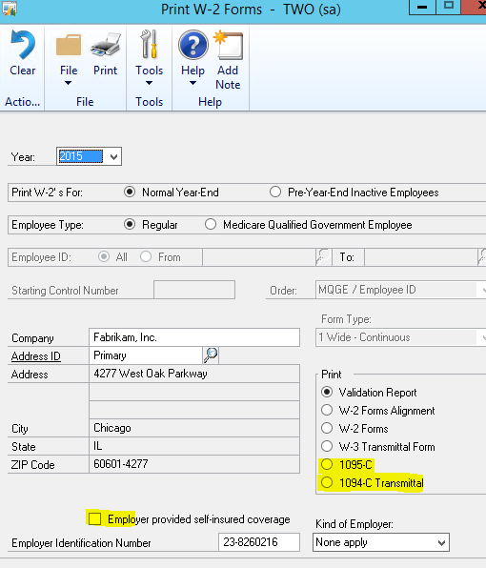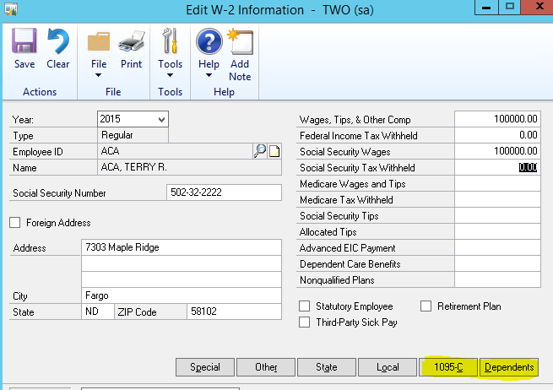

From the EDIT W-2 INFORMATION window you can edit / view the ACA information.

When you remove the year end wage file, all this information will be lost, similar to W2’s, then repopulated when you recreate the year end wage file.

**1095-C Employer Provided Health Insurance Offer and Coverage report**

Void checkbox – no data yet

Corrected checkbox – no data yet

**Part 1 – Employee**

All employee information (name, SSN & address) is taken from the Employee record during the process to create the year end tables. This information can be edited in the Edit W-2 Information window.

All employer information is pulled from the existing year end tables, which can be edited in the Print W-2 window.

**Part 2 – Employee Offer and Coverage**

Offer of Coverage code

* This is determined by looking at the records in UPR00905 (uprMstrEmployeeACA)
* If the Offer of Coverage code has changed twice in one calendar month, the most recent change (based on the Effective Date field) is used. If for example we have made a change on the same day with 2 benefit codes, the system will take the latest change in the table for the month.
* If the Offer of Coverage code has not changed in the past calendar year, the most recent previous change (based on the Change Date field) is used.
  + For example, if the Payroll Year end is being run for 2016, but the last time the Offer of Coverage code was changed for an employee was November 2015, the system will use the code from November.

Employee Share of Lowest Cost Monthly Premium---**changes made in 2015 Year end update**

Per IRS Instructions:

**Line 15.**   Complete line 15 only if code 1B, 1C, 1D, or 1E is entered on line 14 either in the “All 12 Months” box or in any of the monthly boxes. Enter the amount of the employee share of the lowest-cost monthly premium for self-only minimum essential coverage providing minimum value that is offered to the employee.

If the employee is offered coverage but is not required to contribute any amount towards the premium, enter “0.00” (do not leave blank). If the employee share of the lowest-cost monthly premium amount was the same amount for all 12 calendar months, enter that monthly amount in each monthly box **or** enter that monthly amount in the “All 12 Months” box and do not complete the monthly boxes. If the employee share of the lowest-cost monthly amount was not the same for all 12 months, enter the amount in each calendar month for which the employee was offered minimum value coverage.

* This will be the same value for every month; the only exception is if a month has an Offer of Coverage code of 1H or None. Then the value will be 0.
* You can edit this information in the Edit W-2 window as well if the amount is not correct.  
  (In the future, after 2015 year end, we may look to add a new field for this)
* If you need to make a mass change, this is stored in the following year end table UPR10111.  
  At year end time, you can easily do a script to mass change your values based on the lowest coverage that was offered to your employees.
* This field pulls from the UPR00905 table as amounts are added to your employee (LowestCostPremium)
* Microsoft Dynamics GP will print the amount in each monthly box and not update the “All 12 months” field.
* The Lowest Cost Premium field was added to the Human Resource Health Insurance Setup and Health Insurance Enrollment.

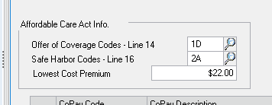

Example

On 1/1, I assigned a benefit to EMP002, Line 14: 1B, Line 16: 2B; Lowest cost: 0.00

On 3/3 I changed lowest cost to 33.33

On 5/5 I set Line 14 to 1A

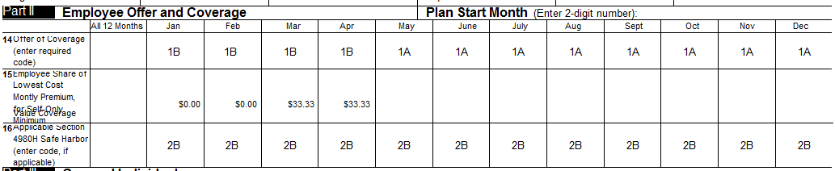

Safe Harbor code

* The Safe Harbor code will be determined in the same manner as the Offer of Coverage code.

Misc Notes:

* If an employee has multiple Active Health Insurance Benefit records, the benefit used is the most recently updated (based on Effective Date).

**Part 3 – Covered Individuals**

Self-insurance coverage checkbox

This is pulled from the Employer provided self-insured coverage checkbox on the Print W-2 Forms window. When marked, the field on the report will be marked for all of the reports printed.   
This is stored in the UPR10100 table new column employer_selfInsured as of 2015 March Hotfix or later

Covered individuals (dependents)

* The data for this section originates from UPR00904 (uprMstrDependentACA); the payroll year end process goes through this data and populates UPR10109 (uprYearEndDependentACA) with records for the selected year.
* The records will print in order of sequence number, which is the order in which they were entered.
* Name, SSN, and DOB are all from the Employee Dependent window (uprMstrDependent table)
* Covered all 12 months is calculated during the payroll year end process based on the current dependent records. If the individual had coverage as of 1/31 of that payroll year, they would be considered covered (provided there were no later records that would change that)
* If an individual’s coverage changed more than once in a calendar month, the last record of that month would be the one used to determine coverage.
* An employee is considered not covered for a month, if that month had an Offer of Coverage code of 1H or None.
* If an individual’s coverage records start mid-year (for example, March), then they are considered to be not covered up to that point (so January and February checkboxes would be unmarked).

**Year End tables of interest**

* UPR10100 (UPR_Year_End_WORK_HDR)
  + Added Employer Self-Insured field
* UPR10108 (uprYearEndDependentACAHistory)
  + This is a copy of the uprMstrDependentACA table for the reporting year
* UPR10109 (uprYearEndDependentACA)
  + New table that contains the dependent data for Part 3 of the 1095-C report
* UPR10110 (uprYearEndEmployeeACAHistory)
  + This is a copy of the uprMstrEmployeeACA for the reporting year
* UPR10111 (uprYearEndEmployeeACA)
  + New table that contains the data for Part 2 of the 1095-C report

**Forms Added/Updated**

* Print W-2 (UPR_Year_End_Wage_Forms_Printing)
* Edit W-2 (UPR_Year_End_Editing_W2)

**Reports Added/Updated**

* 1094-C Transmittal of Employer Health Ins
* 1095-C Employer-Provided Health Insurance

**Misc notes:**

-If an employee does not have an insurance code assigned, they could still get a 1095-C printed for them, as long as they have a dependent record (table UPR00904)

-Employees that are marked as Inactive will get a 1095-C if they have a dependent record in UP00904.

-Employees that do not have wages but ACA data will also get a 1095-C

**1094-C Transmittal of Employer Health Ins**

**Part 1**

All employer information is pulled from the existing year end tables, which can be edited in the Print W-2 window.

**Fields that are blank are not currently stored in Microsoft Dynamics GP for this specific report**

**Part 2**

Not populated as information is not stored in Microsoft Dynamics GP.

**Part 3**

Not populated as information is not stored in Microsoft Dynamics GP.

If you reinstalled the sample company Fabrikam, you may not see the ACA codes in the look up. Run the below script to repopulate them, this is only an issue in Fabrikam company when you reload sample data.

insert into upr40105

(ten95line, ten95linecode, ten95linecodetext, ten95linedescription)

values

(1,1,'1A',' ')

insert into upr40105

(ten95line, ten95linecode, ten95linecodetext, ten95linedescription)

values

(1,2,'1B',' ')

insert into upr40105

(ten95line, ten95linecode, ten95linecodetext, ten95linedescription)

values

(1,3,'1C',' ')

insert into upr40105

(ten95line, ten95linecode, ten95linecodetext, ten95linedescription)

values

(1,4,'1D',' ')

insert into upr40105

(ten95line, ten95linecode, ten95linecodetext, ten95linedescription)

values

(1,5,'1E',' ')

insert into upr40105

(ten95line, ten95linecode, ten95linecodetext, ten95linedescription)

values

(1,6,'1F',' ')

insert into upr40105

(ten95line, ten95linecode, ten95linecodetext, ten95linedescription)

values

(1,7,'1G',' ')

insert into upr40105

(ten95line, ten95linecode, ten95linecodetext, ten95linedescription)

values

(1,8,'1H',' ')

insert into upr40105

(ten95line, ten95linecode, ten95linecodetext, ten95linedescription)

values

(1,9,'1I',' ')

insert into upr40105

(ten95line, ten95linecode, ten95linecodetext, ten95linedescription)

values

(2,1,'2A',' ')

insert into upr40105

(ten95line, ten95linecode, ten95linecodetext, ten95linedescription)

values

(2,2,'2B',' ')

insert into upr40105

(ten95line, ten95linecode, ten95linecodetext, ten95linedescription)

values

(2,3,'2C',' ')

insert into upr40105

(ten95line, ten95linecode, ten95linecodetext, ten95linedescription)

values

(2,4,'2D',' ')

insert into upr40105

(ten95line, ten95linecode, ten95linecodetext, ten95linedescription)

values

(2,5,'2E',' ')

insert into upr40105

(ten95line, ten95linecode, ten95linecodetext, ten95linedescription)

values

(2,6,'2F',' ')

insert into upr40105

(ten95line, ten95linecode, ten95linecodetext, ten95linedescription)

values

(2,7,'2G',' ')

insert into upr40105

(ten95line, ten95linecode, ten95linecodetext, ten95linedescription)

values

(2,8,'2H',' ')

insert into upr40105

(ten95line, ten95linecode, ten95linecodetext, ten95linedescription)

values

(2,9,'2I',' ')